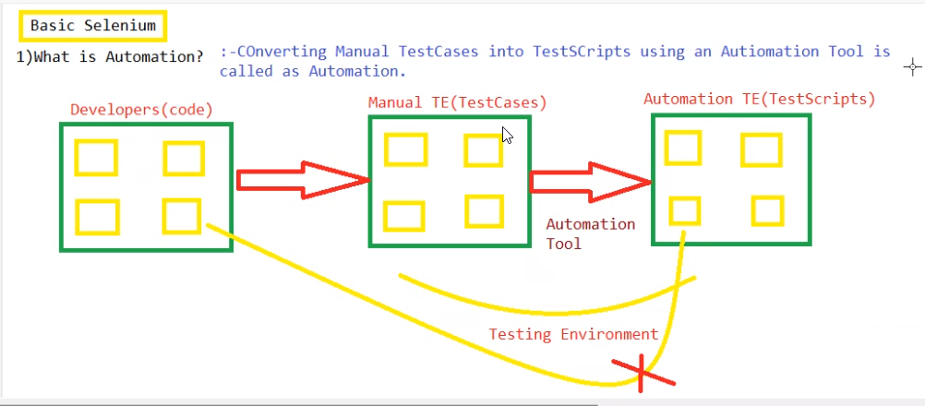

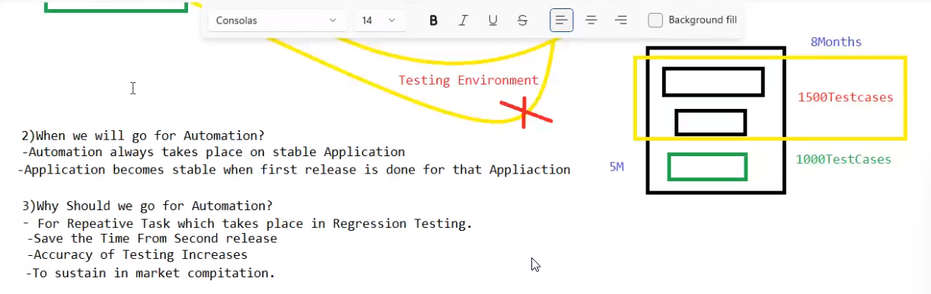

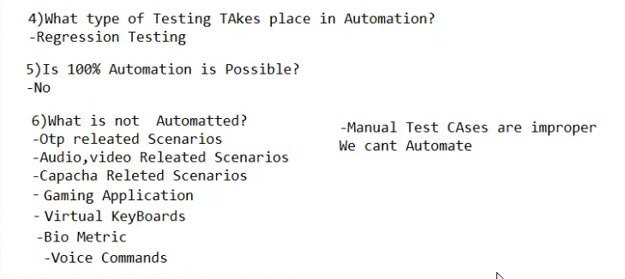

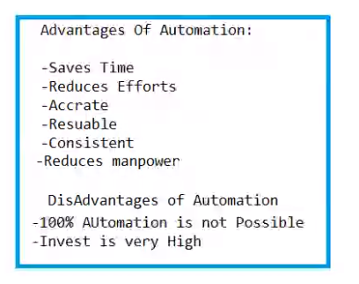

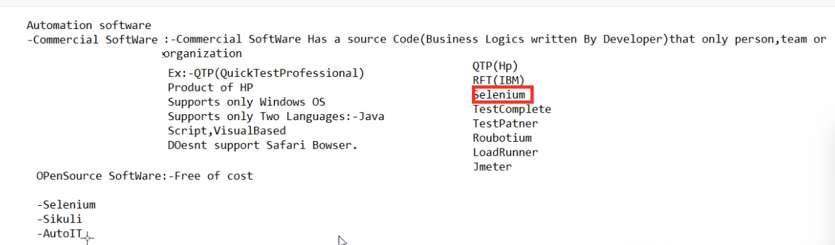

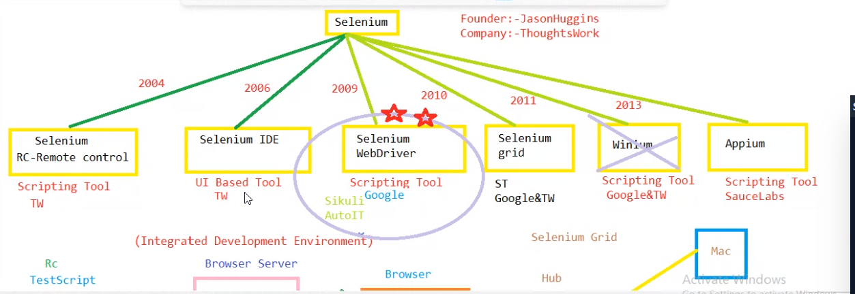

Selenium RC did not boom because of browser server

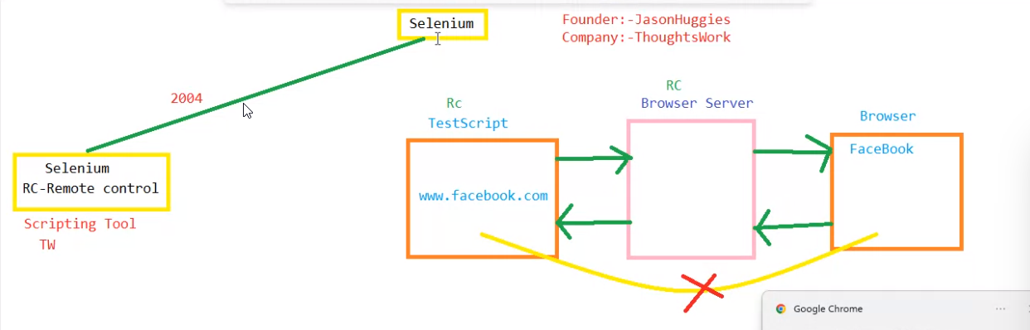

Hub and note execution.

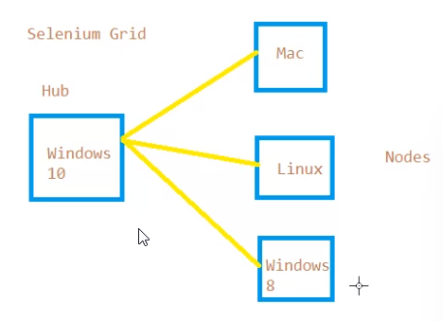



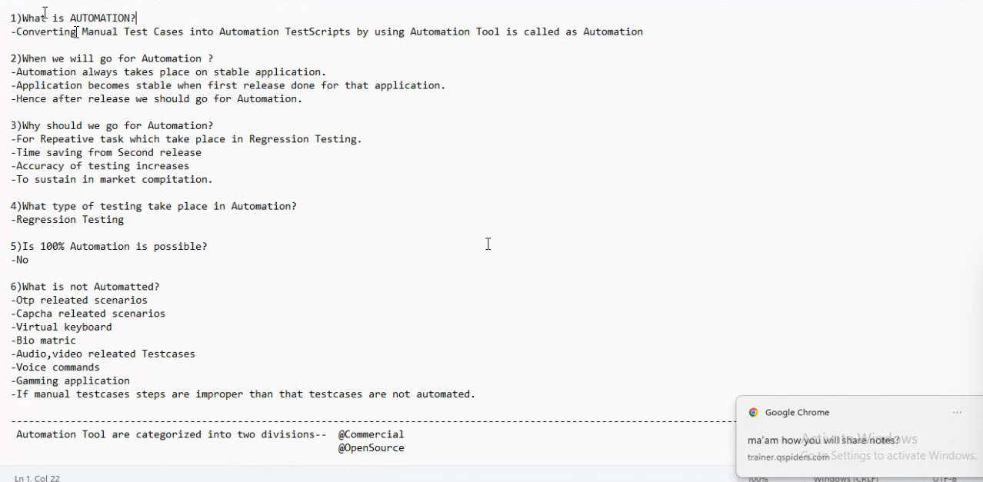

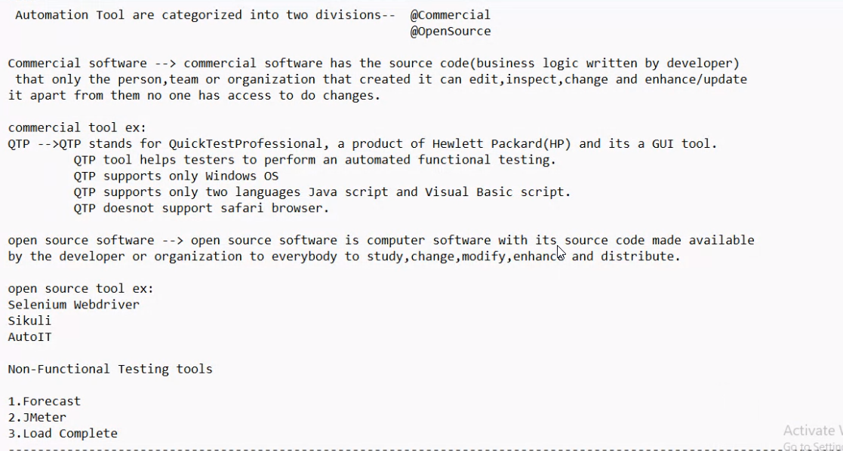

**Selenium web driver**

Supports all the languages and platforms.

Supports all the web browsers.

Supports browsers server for each web browsers.

Communication always happens with browser servers between test scripts and web browsers

Selenium-3 Architecture

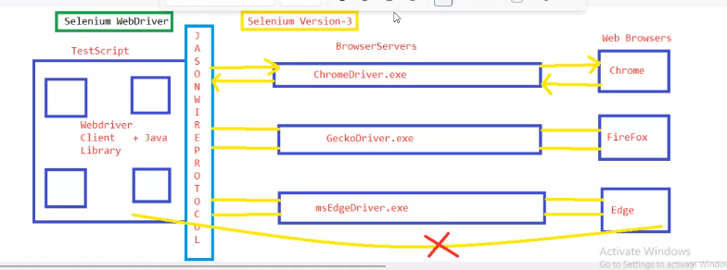

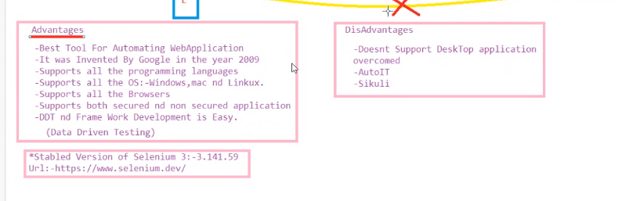

selenium 4(2021)

world wide web consortium

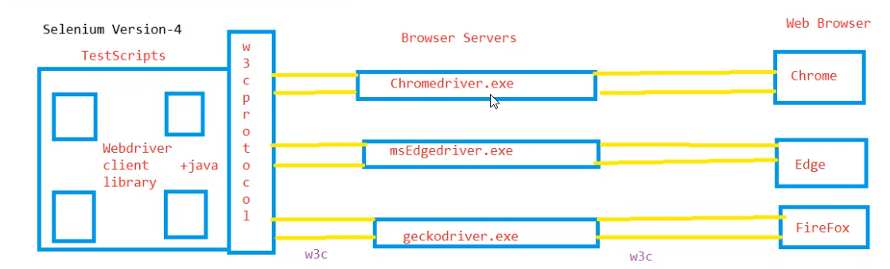

performance is increased and optimizing the code is easy

test scripts was communicating with java language itself with browsers

Softwares:

Jdk 17 , eclipse 22/23

Selenium Java Architecture

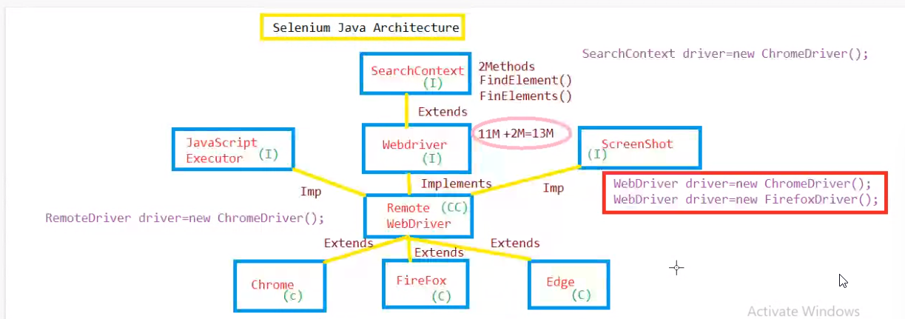

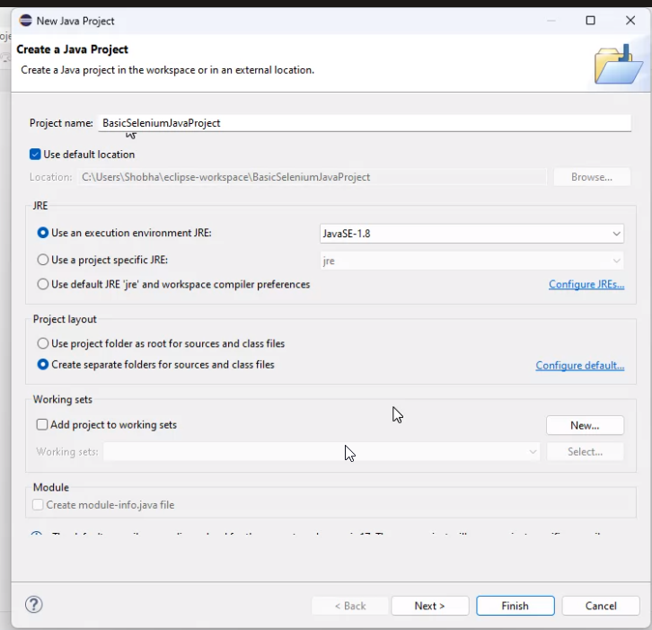

Maven Project

File🡪new—project🡪maven(plugin)🡪next-🡪check first checkbox(create a simple project)

Group id---organization name

Artifact id---name of project

After creating maven project

Add selenium tool in pom.xml by copying dependencies from mvn repository

Search with seleniumjava and select version most usaged one

Update the project----pom.xml🡪rightclick🡪maven🡪update project🡪chekck force update🡪0k

Add browser server (Add chrome exe) in project copy and paste exe

Create projects in src/test/java

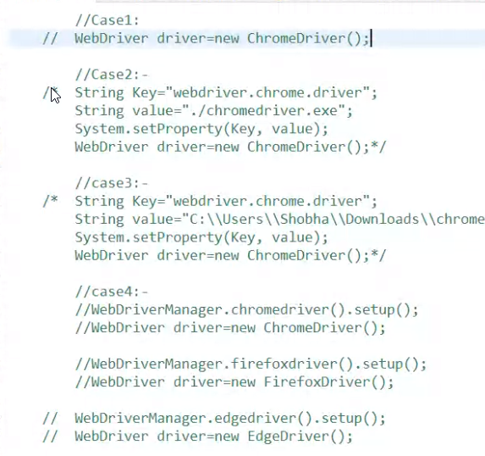

Selenium Dependencies

Version: 3.141.59

WebDrivermanager dependencies

It manages the browser versions

Version changes may impact the scripts if we add these dependencies in pom.xml it will automatically update the browser version changes

If we add webDriverMnager dependencies then no need to add .exe files

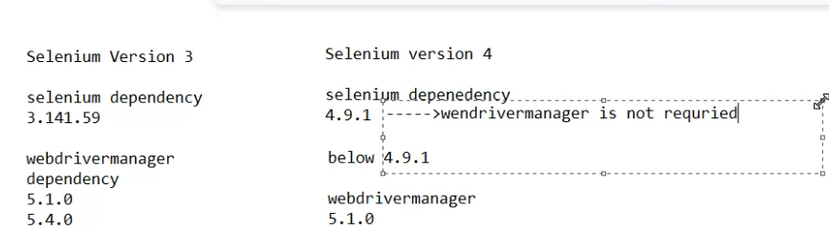

Version3

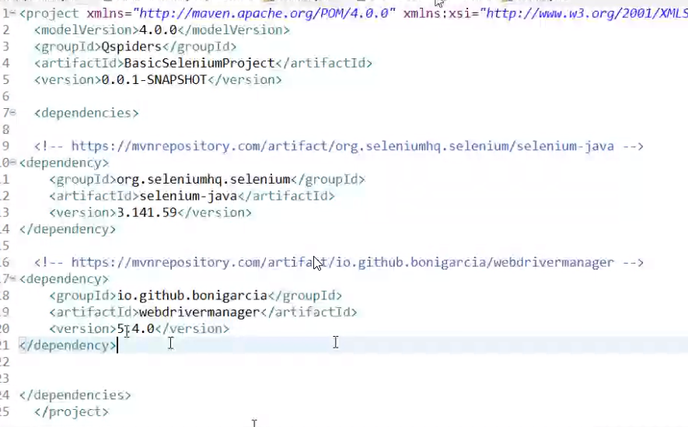

Version4

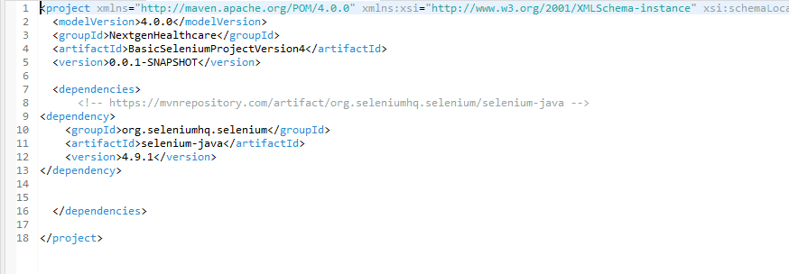

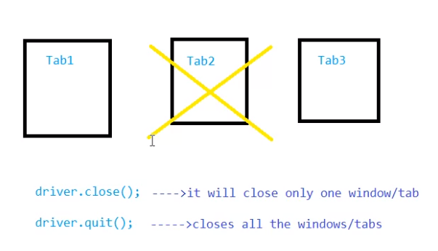

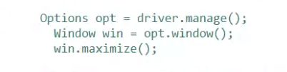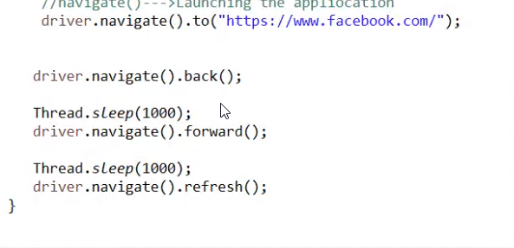

Locators:

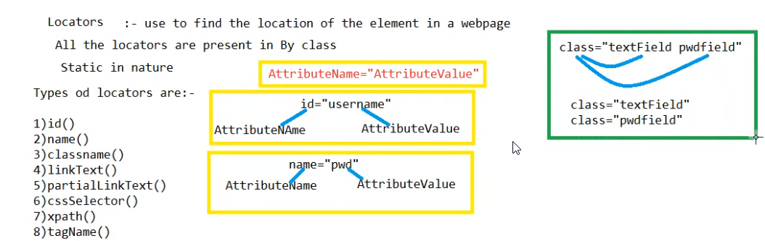

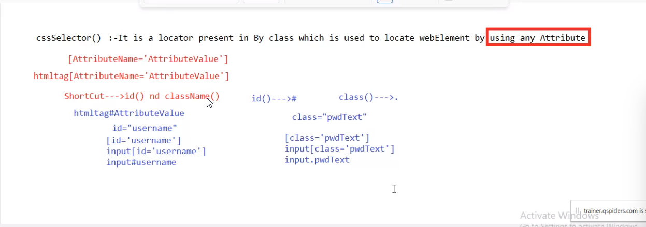

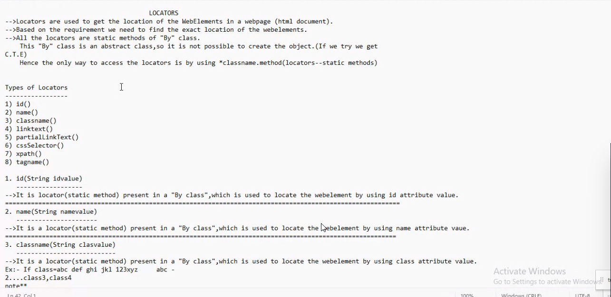

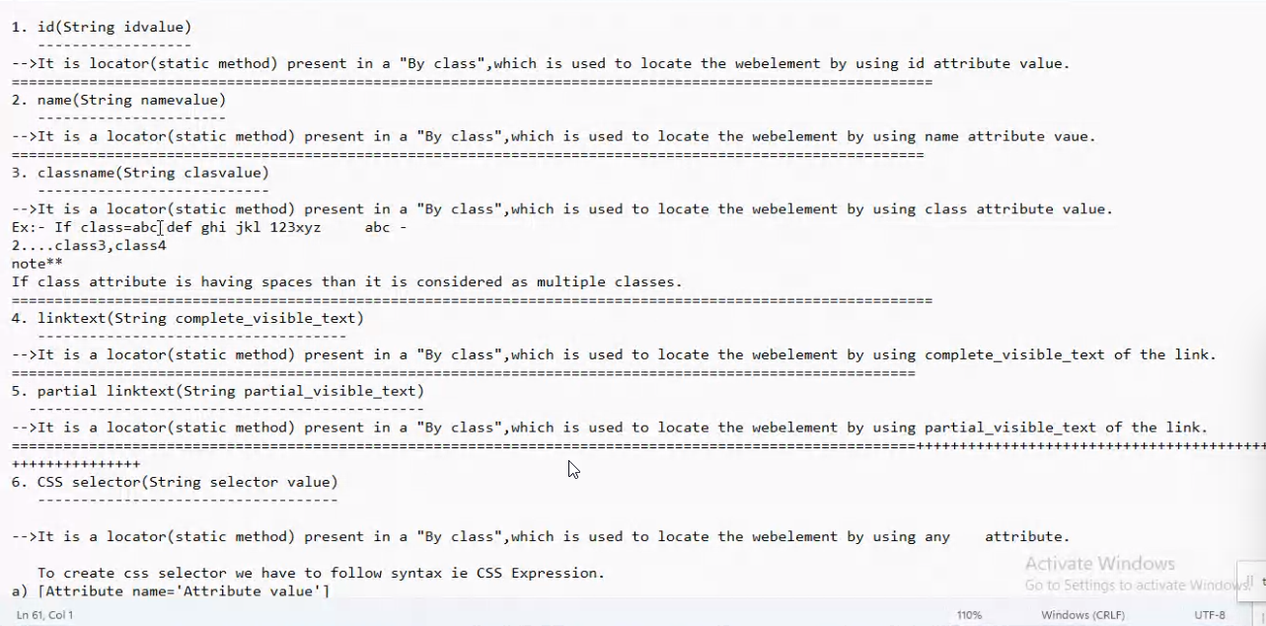

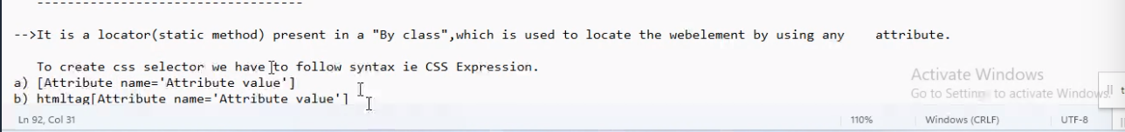

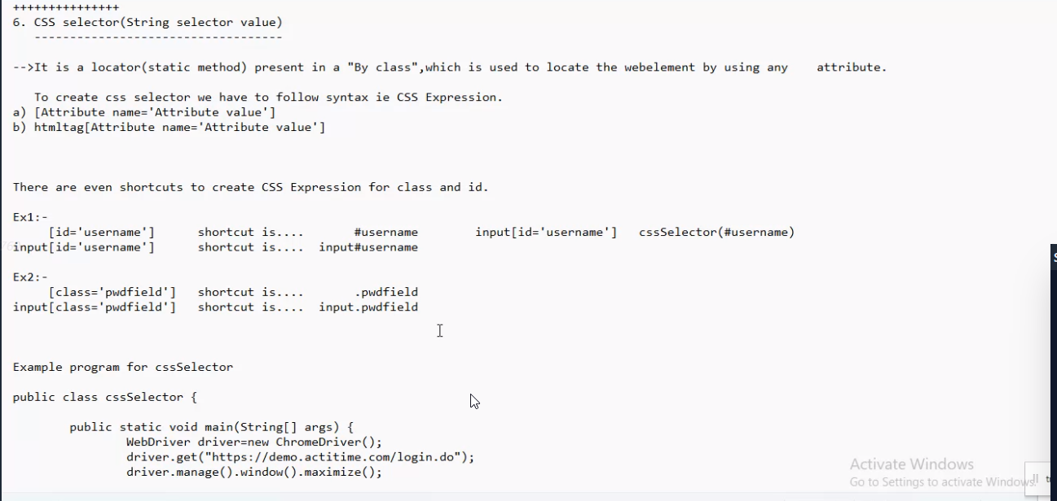

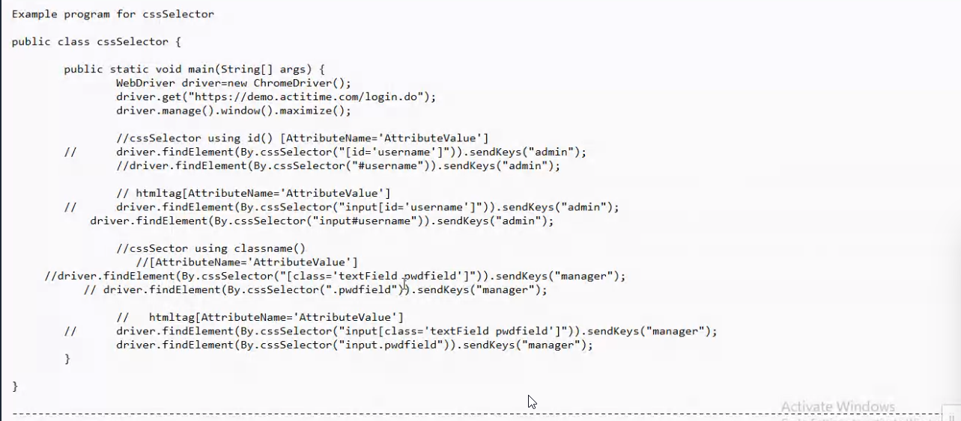

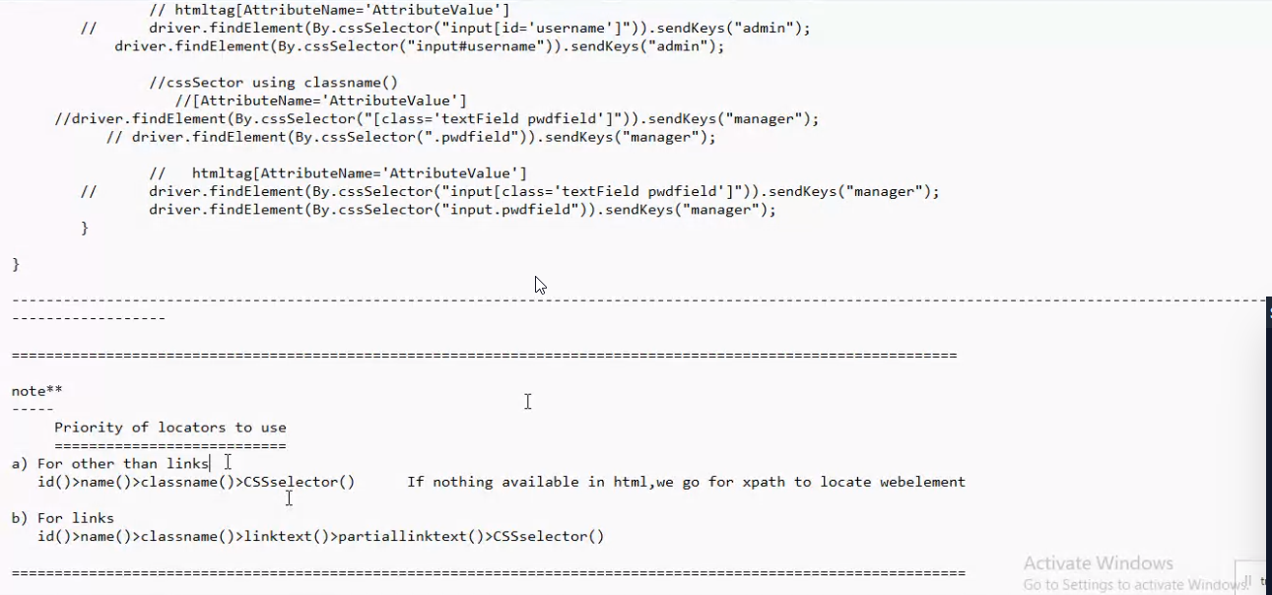

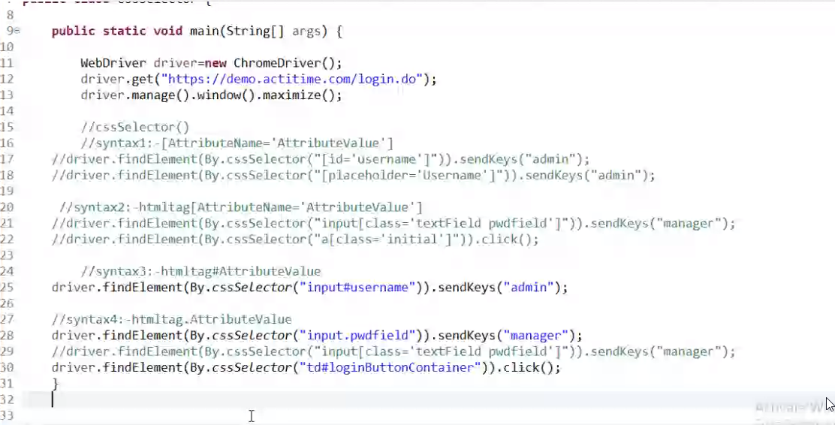

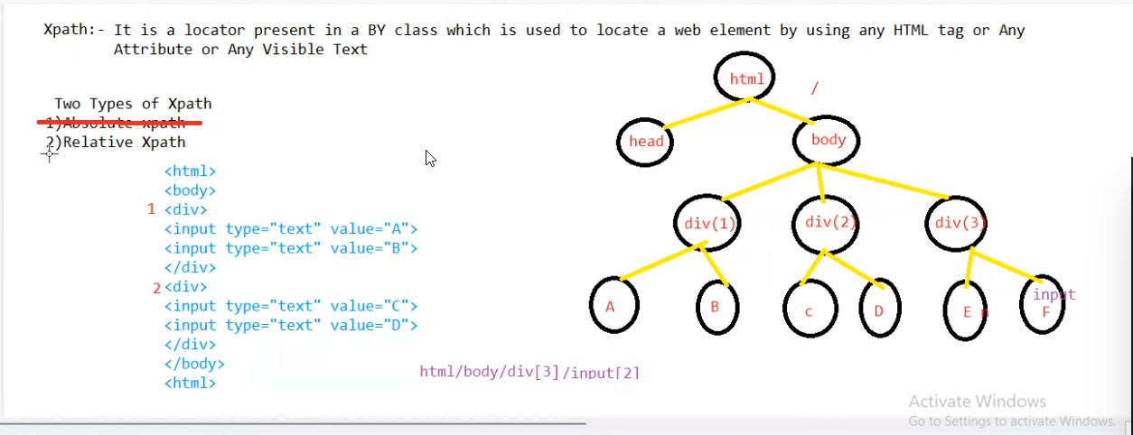

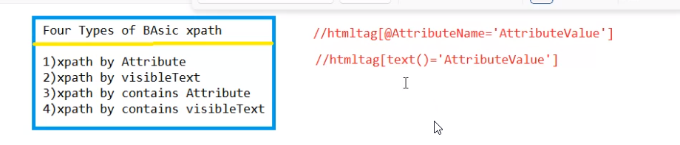

2nd type xpath

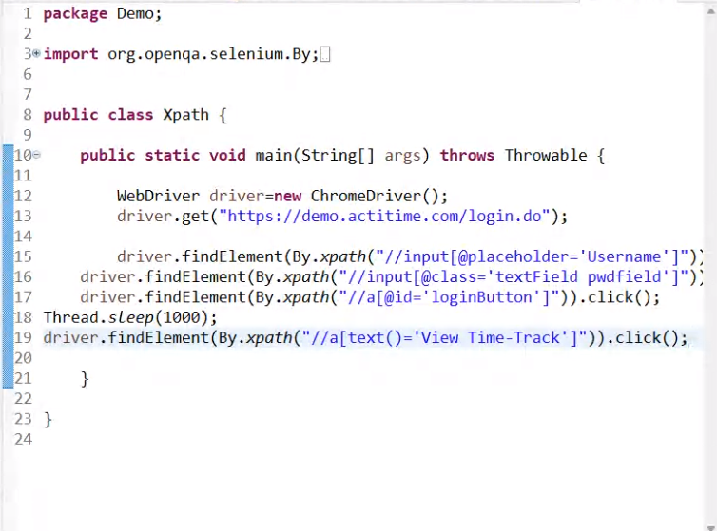

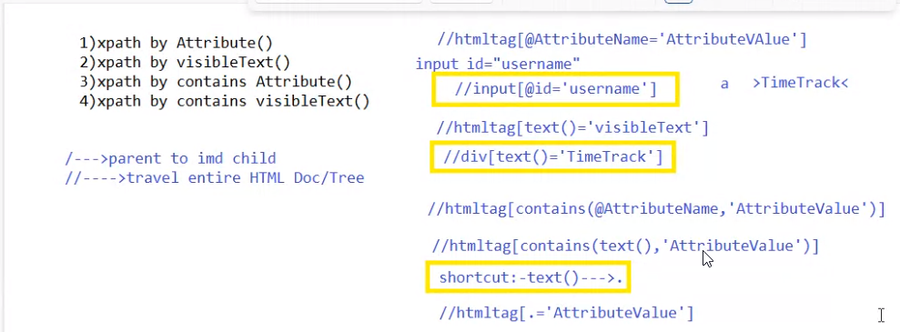

We go for contains when there is numeric values in the path and for dynamic objects contains numbers

Xpath by multiple attributes

Using AND and OR

Basically for svg objects handling

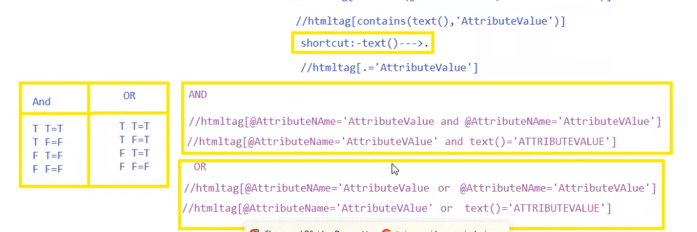

Backward traversing

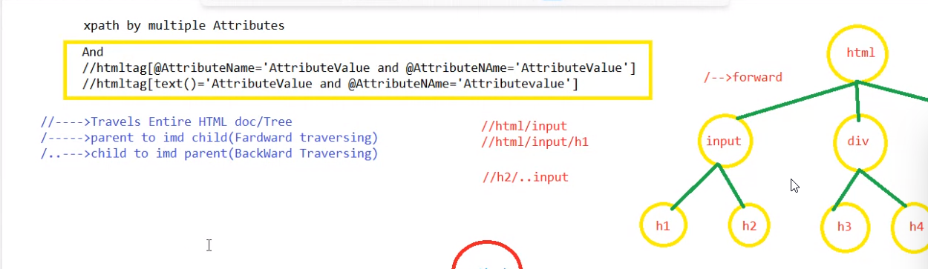

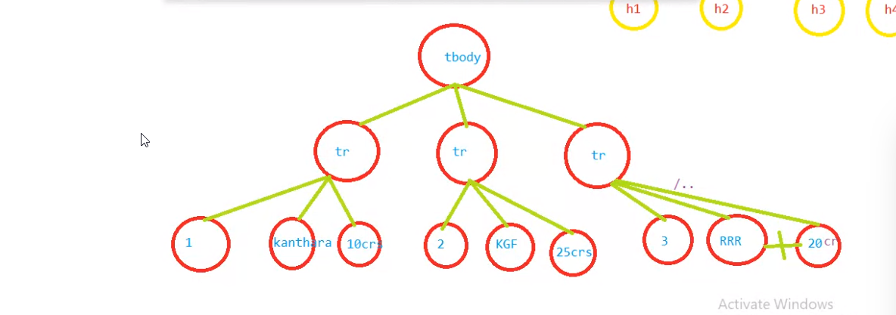

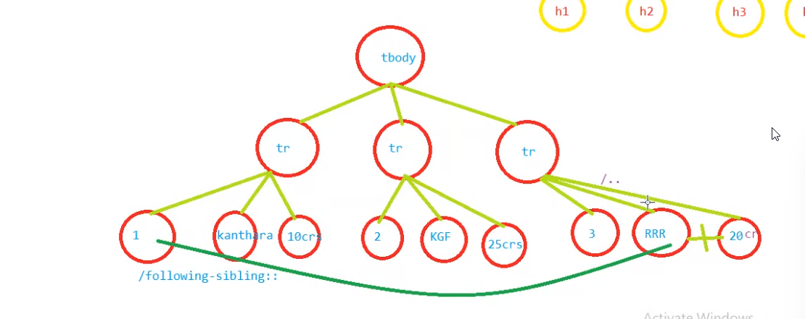

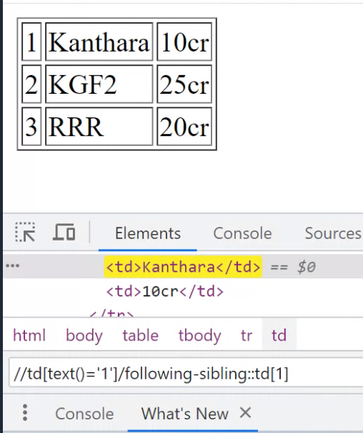

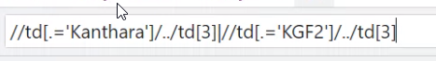

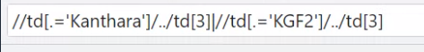

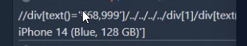

Pipeline

To select multiple items in the table

Refer backward traversing html

Iphone price xpath



Using following sibling

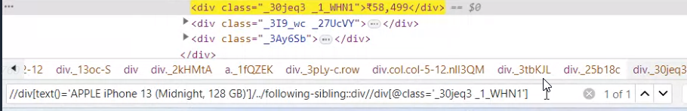

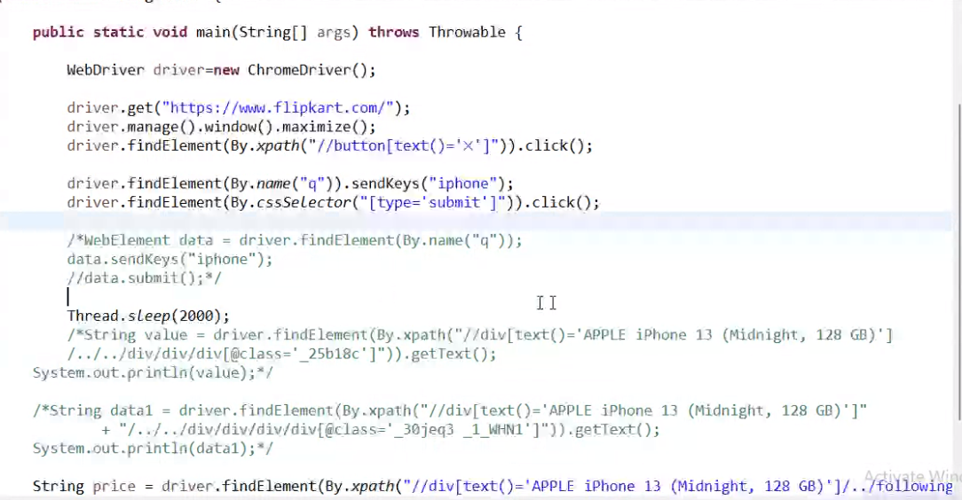

Preceding sibling

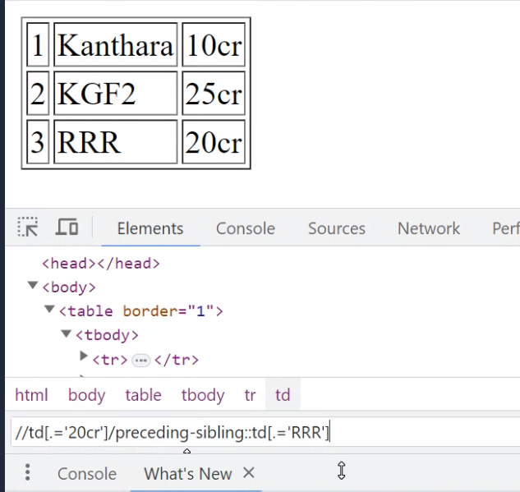



Group by index

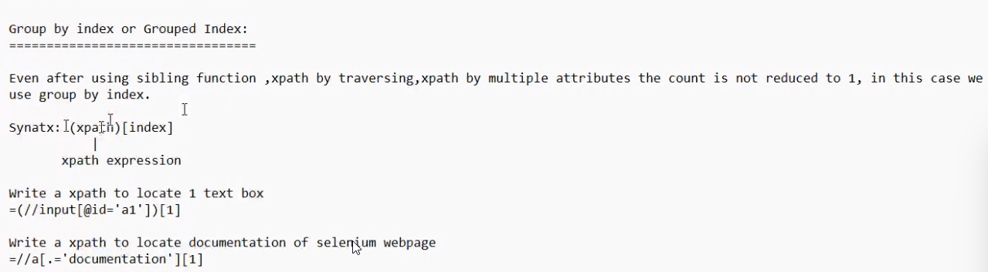

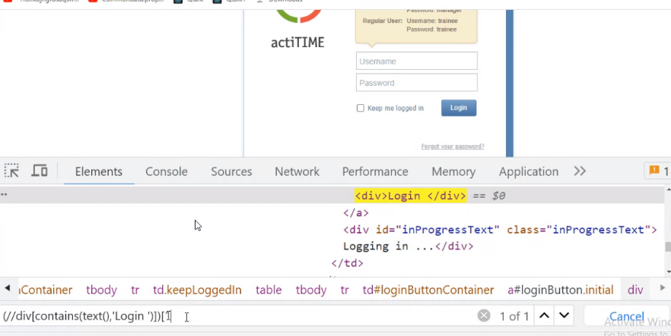

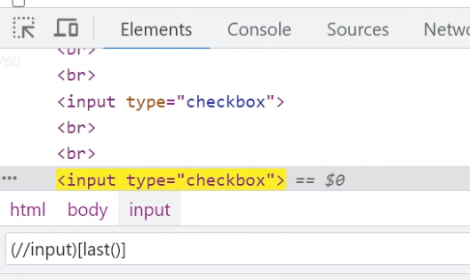

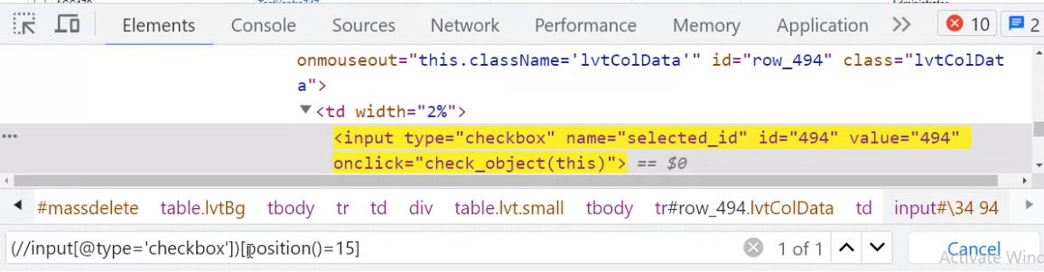

Even checkboxes

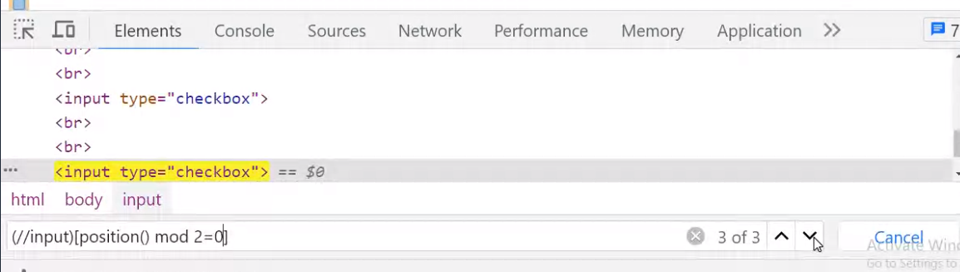

WebElement methods

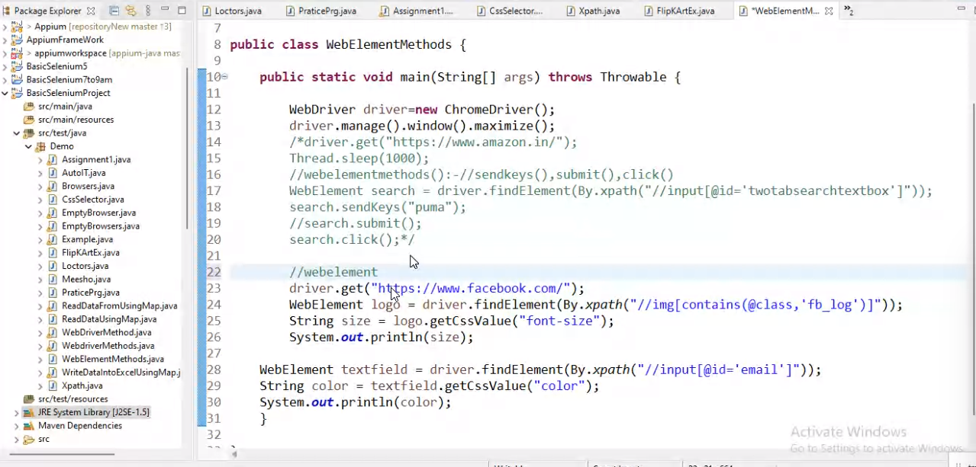

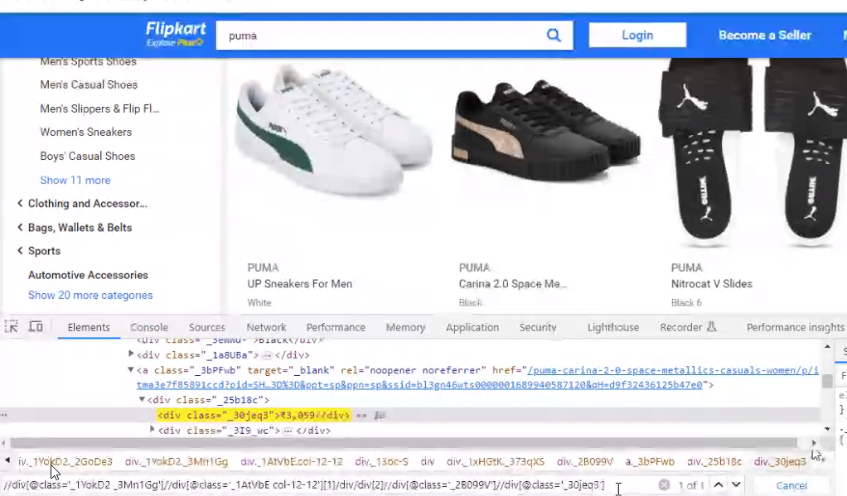

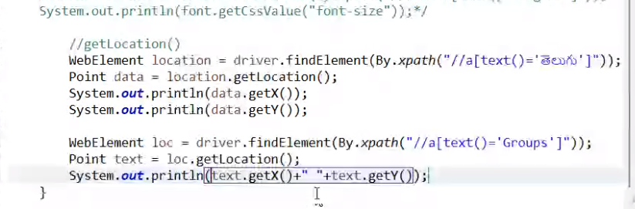

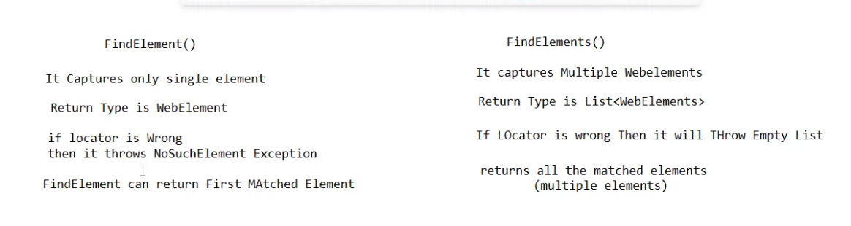

Autosuggestions

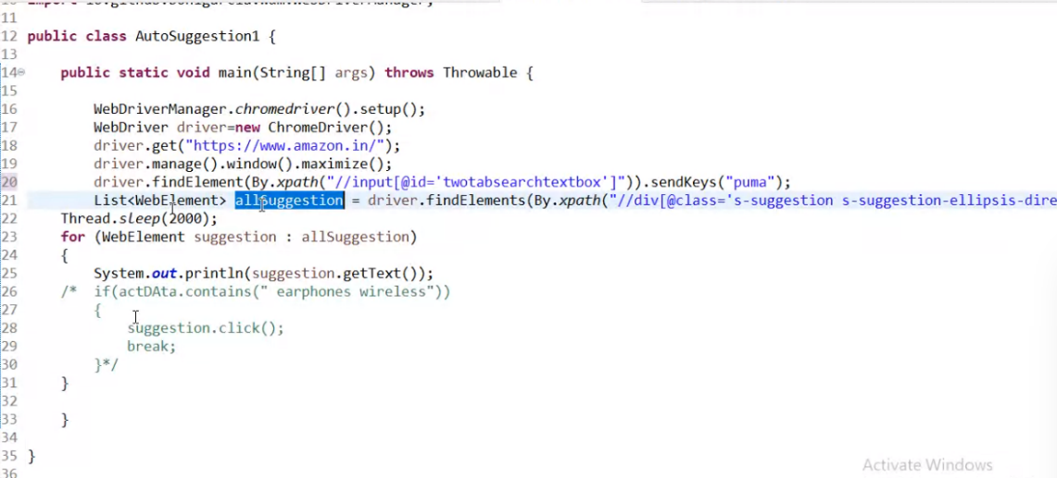

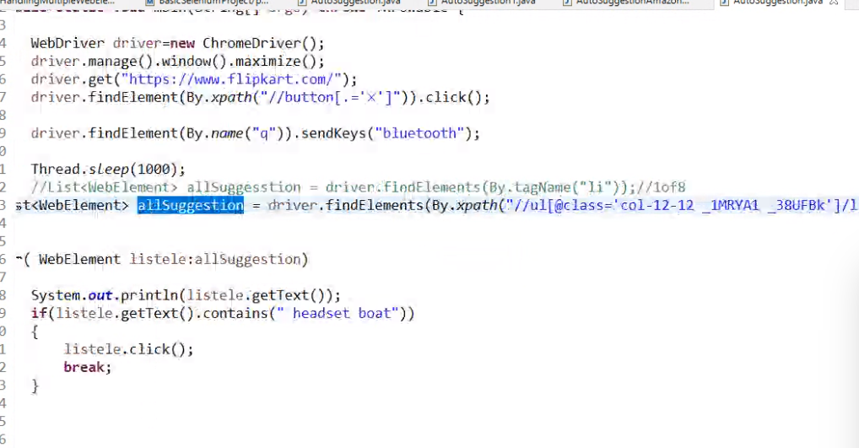

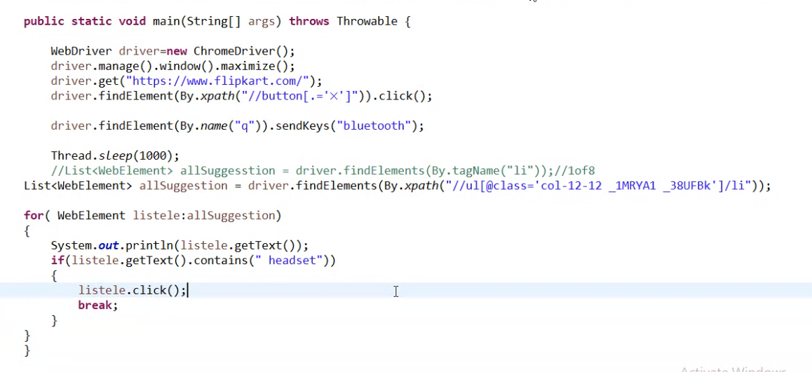

Flipkart_autosuggetsion

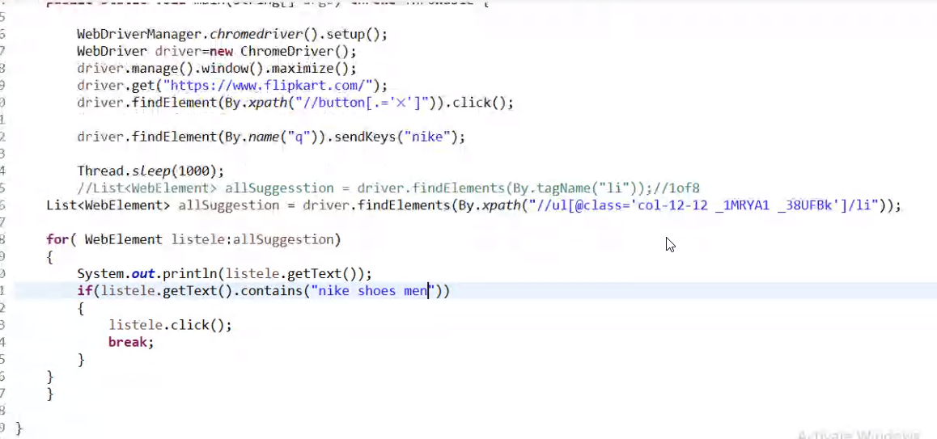

Key class

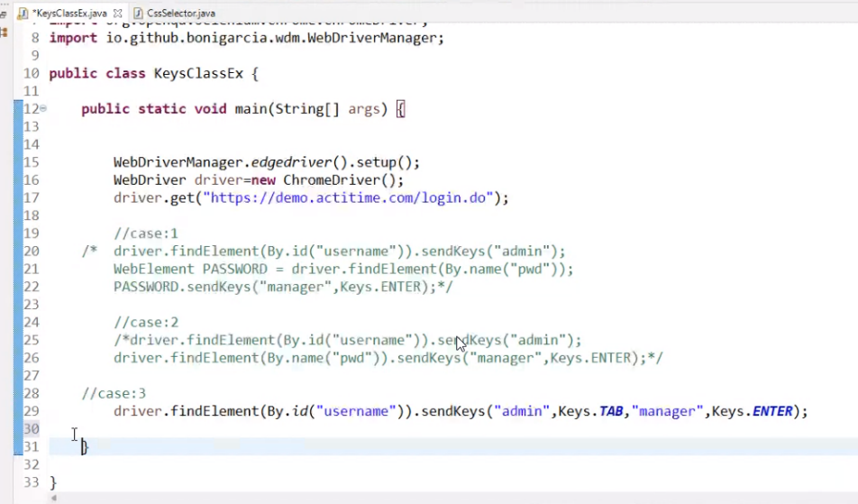

Robot class

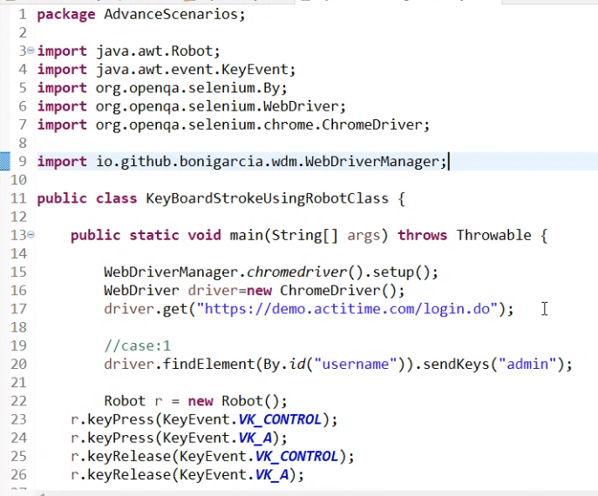

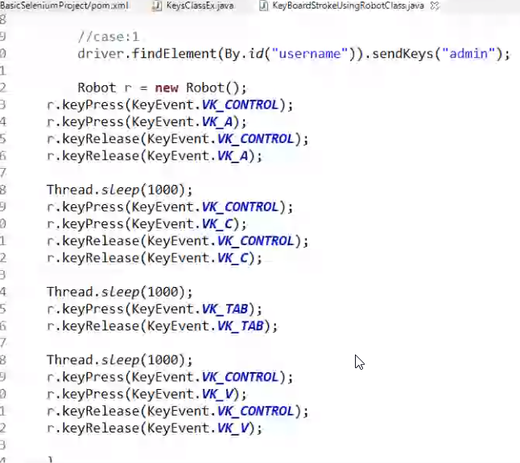

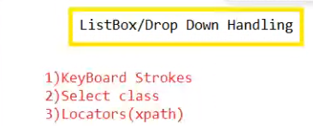

Listbox handling

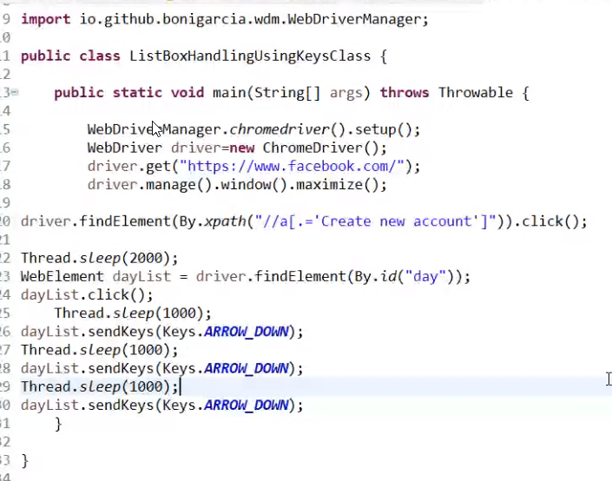

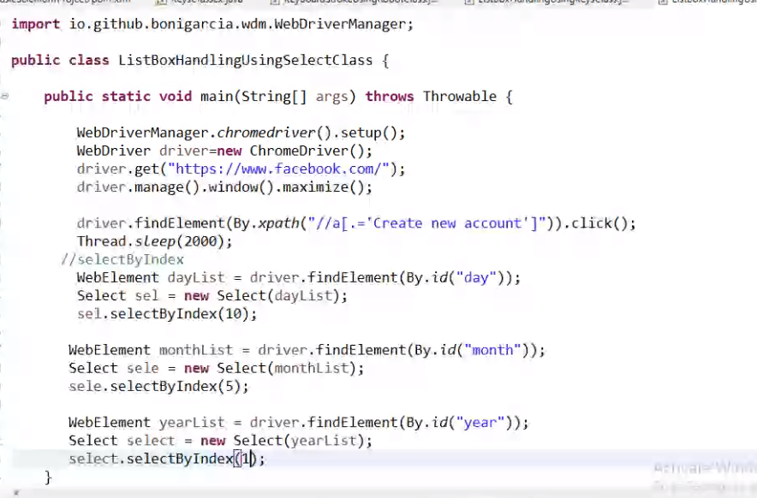

Advanced scenario overview

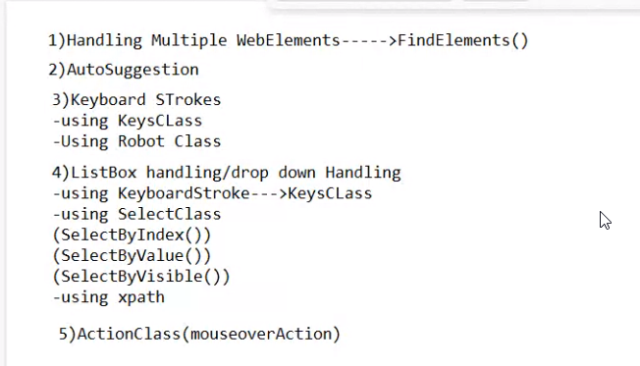

Scroll handling

1.robot class

2.Javascript executor

Handle svg elements

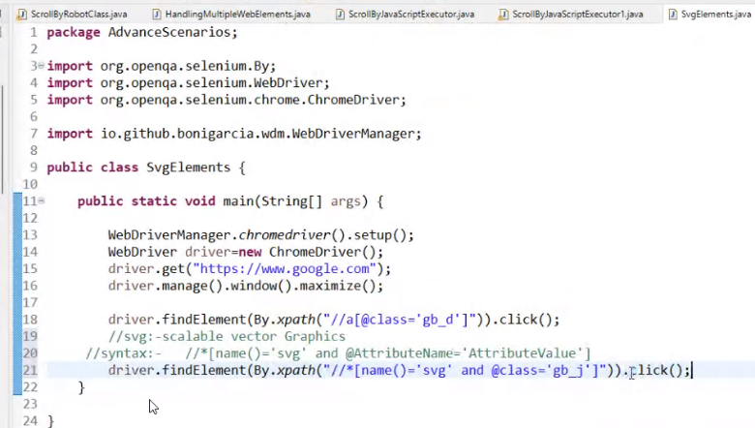

Dynamic xpath

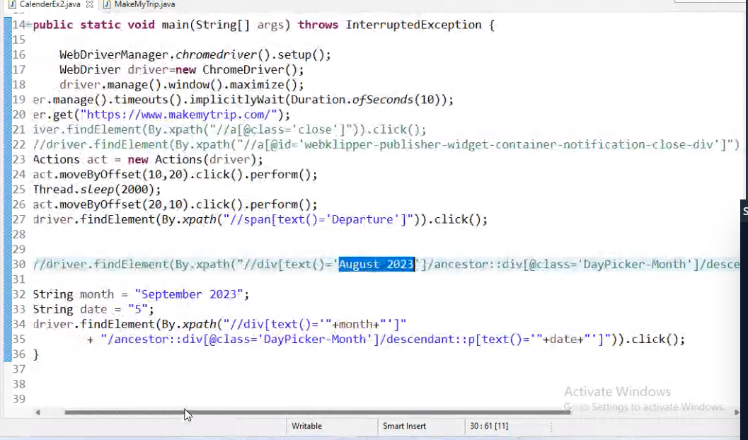

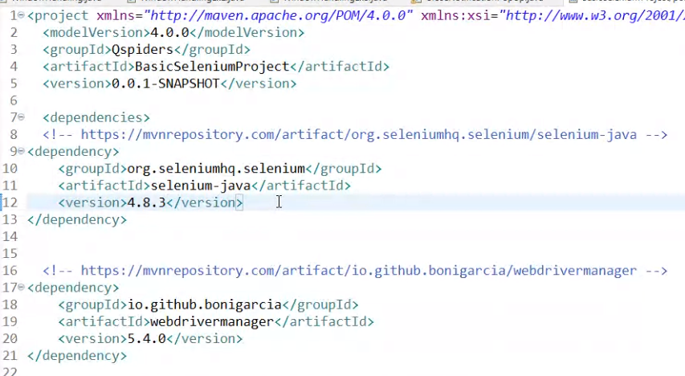

File upload pop up

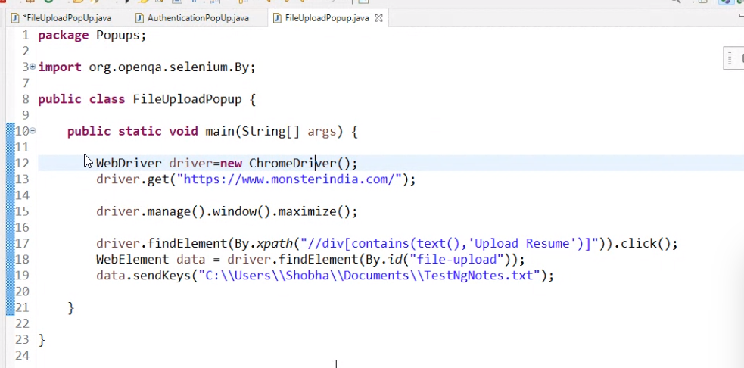

Private windows

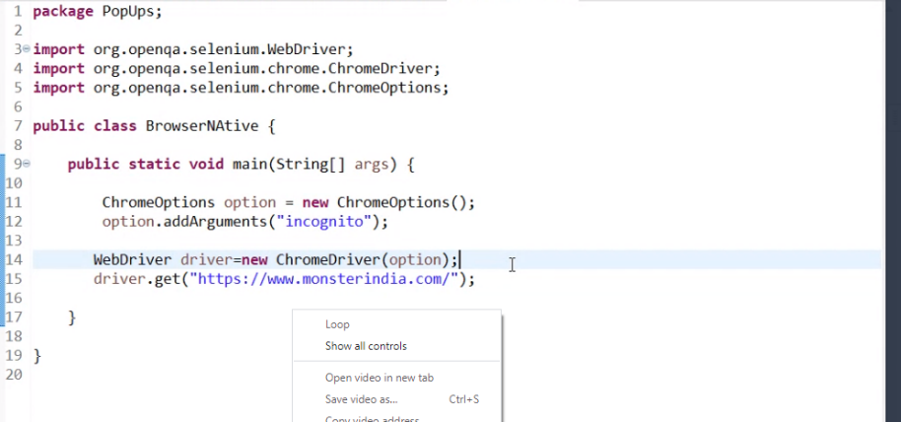

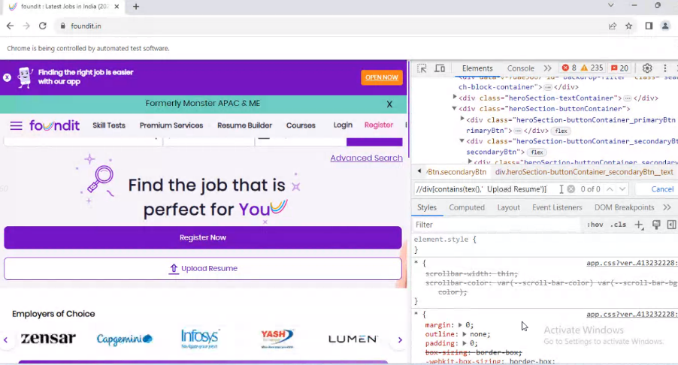

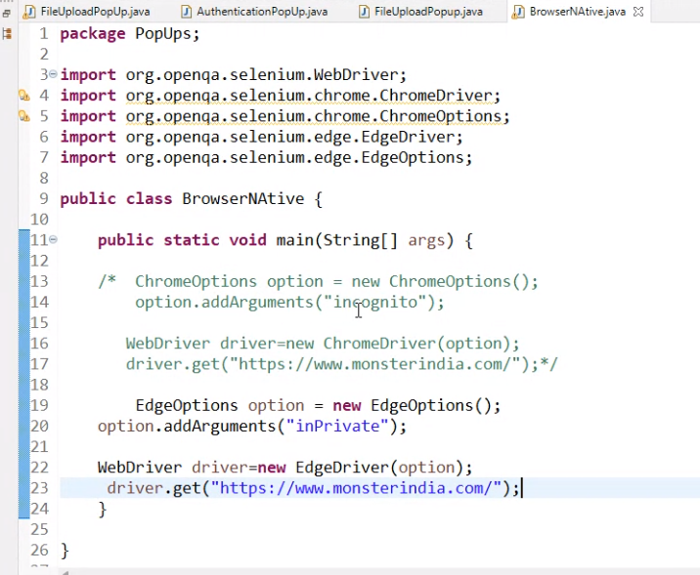

Handling frames

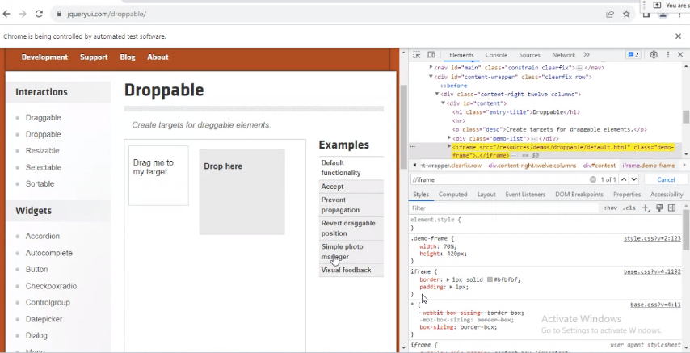

Frames using index

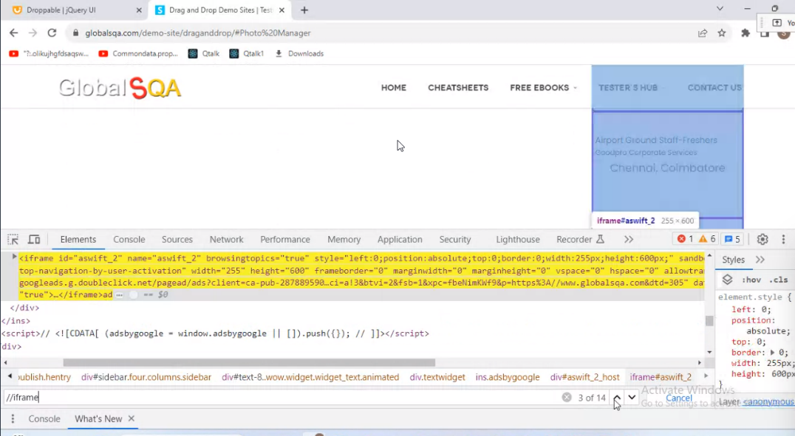

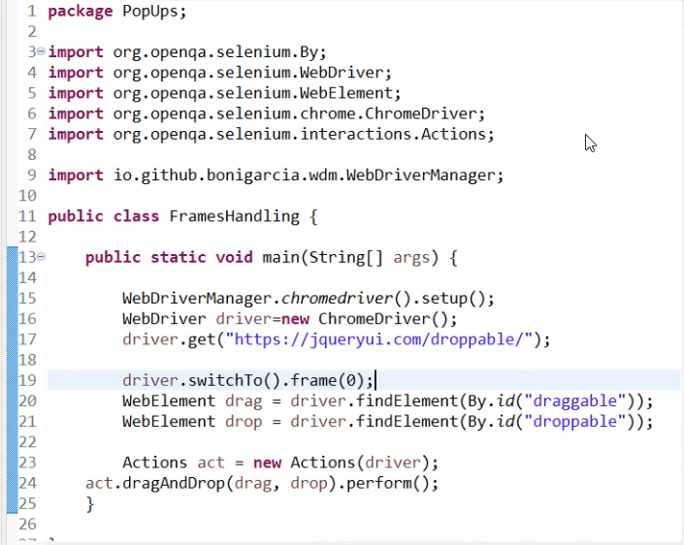

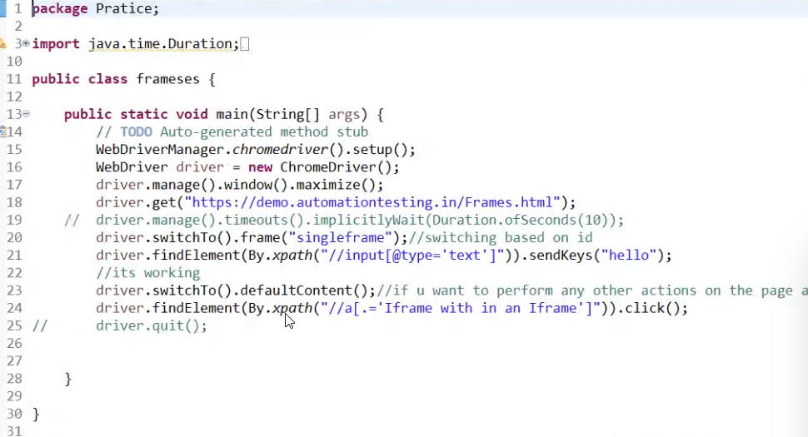

Handle frames using id/name

<https://demo.automationtesting.in/Frames.html>

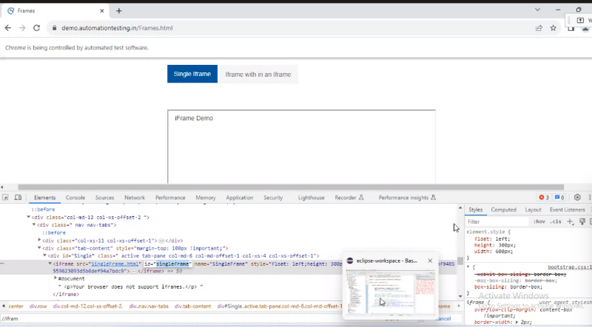

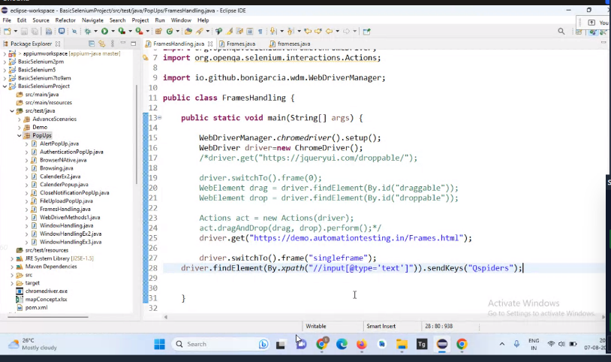

Switch back to min window

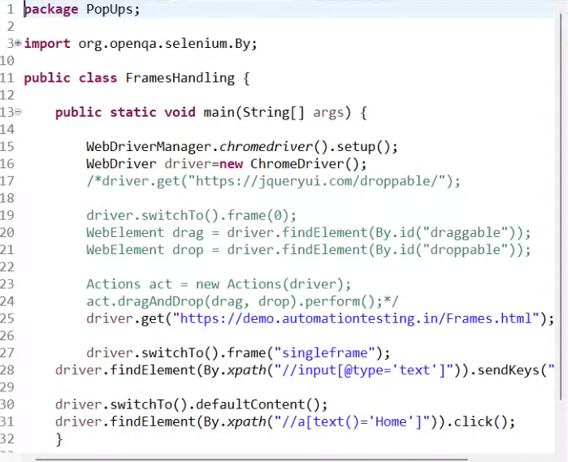

Using web element switch to frame

3 approach: by using index, using id/name, using webelement

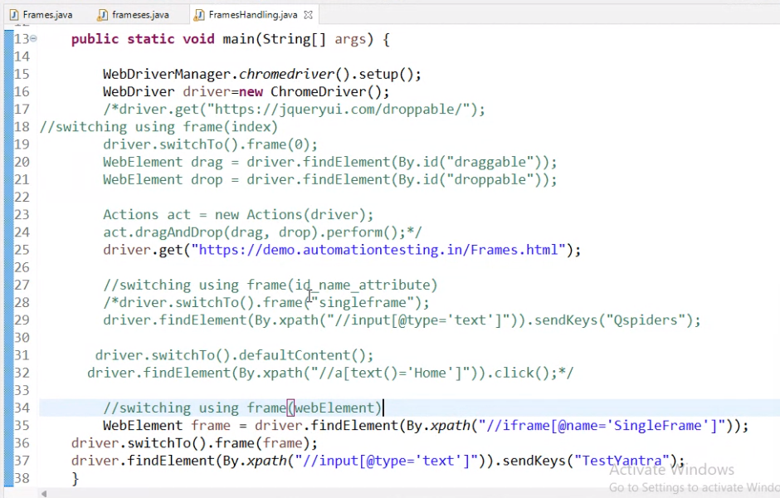

HIDDEN DIVISION POP UP

After performing some actions we could see the pop ups

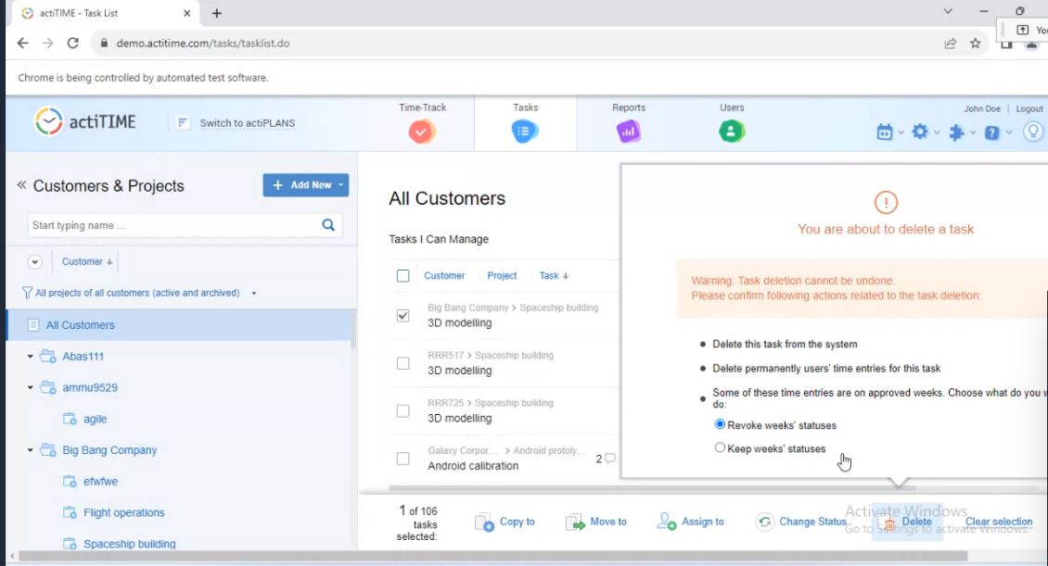

Framework

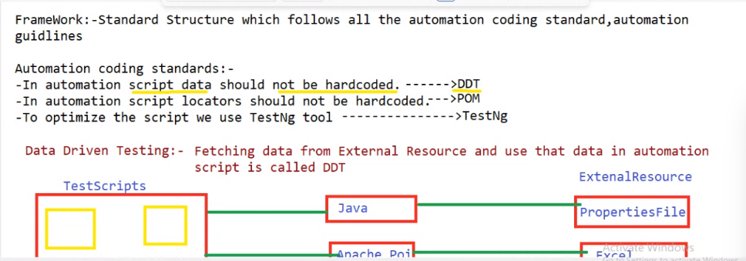

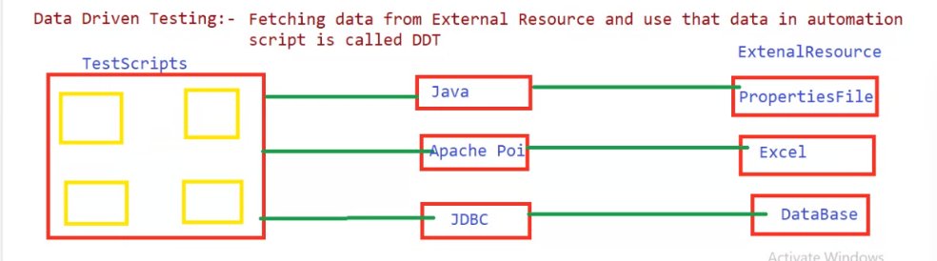

Key and value pair in notepad.properties

Paste it is in src/test/resource

Fetching data from excel

1.add dependency in pom

Apache poi and apcahe poi xml

POM---avoid locators hardcoding

POM class

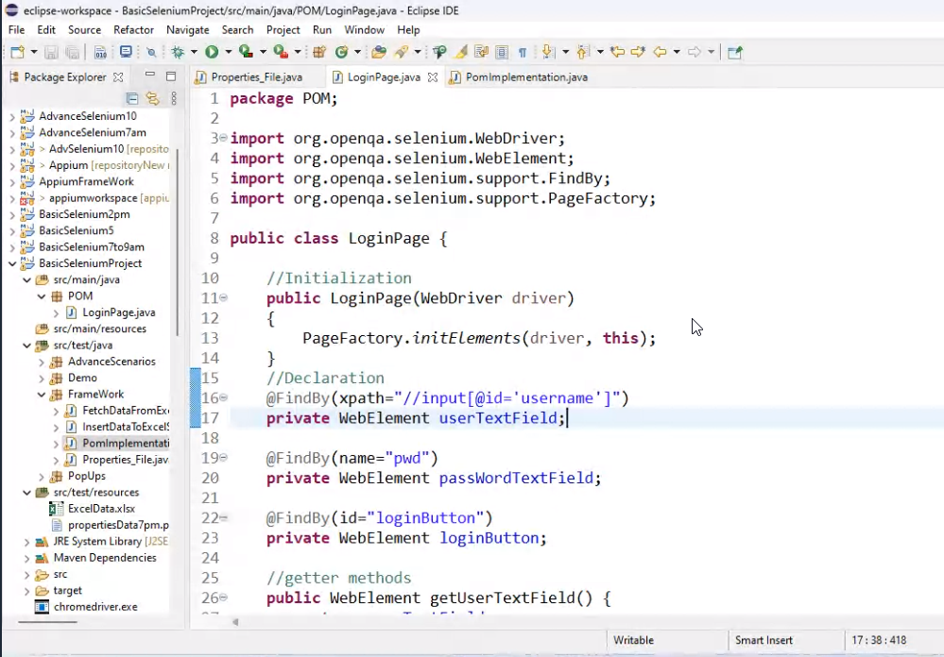

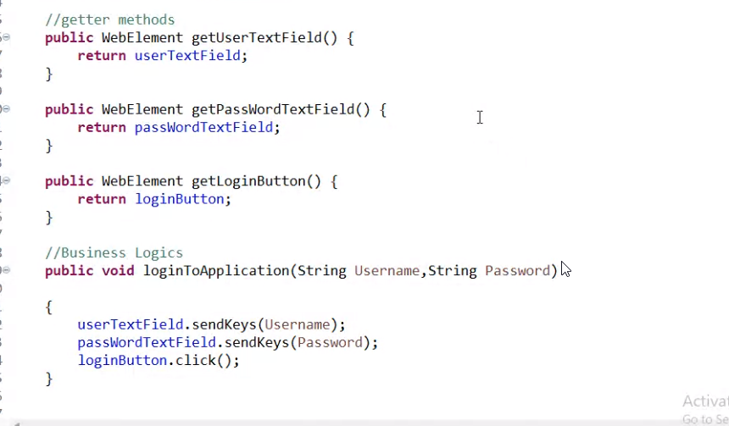

POM class Implementation

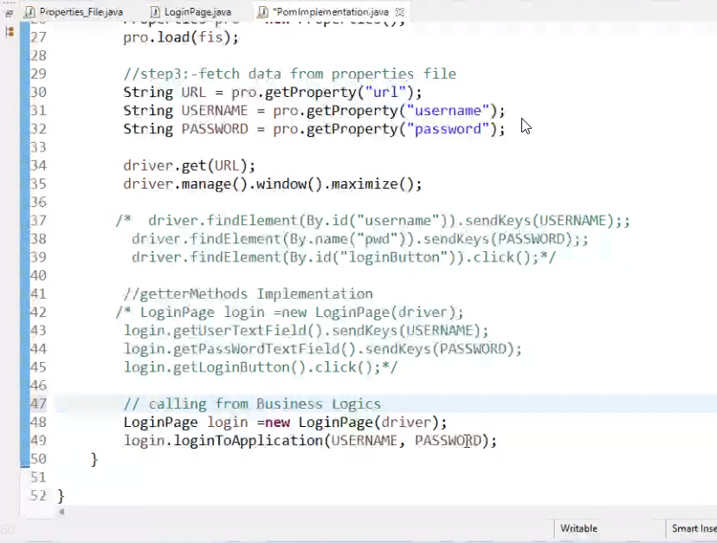

StaleElementException

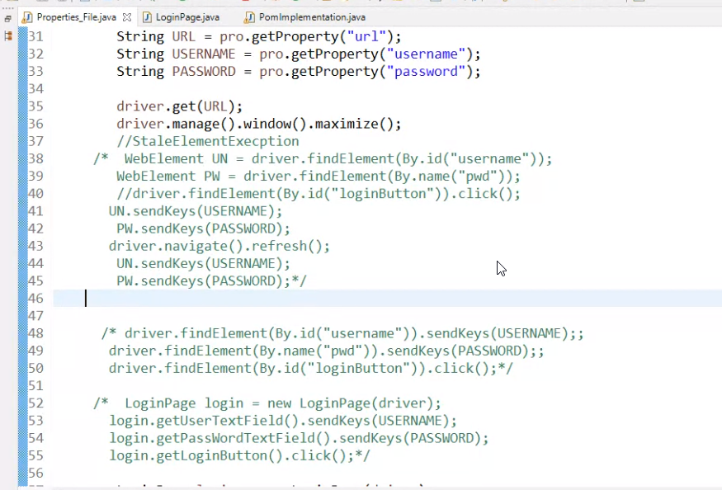

TestNG

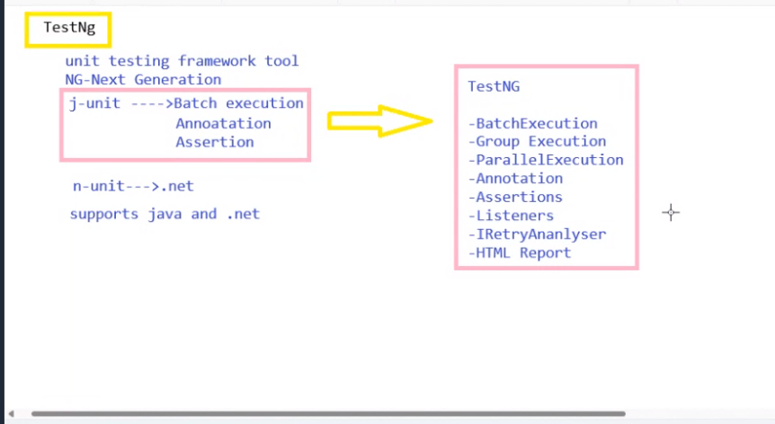

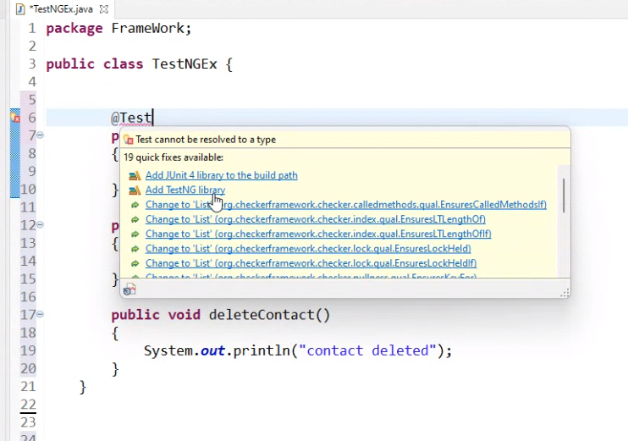

Run only single method

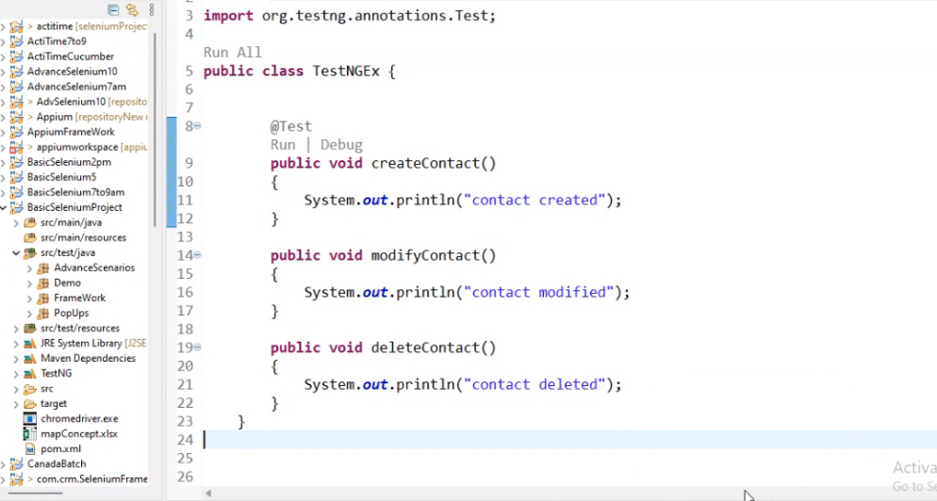

Run all the methods

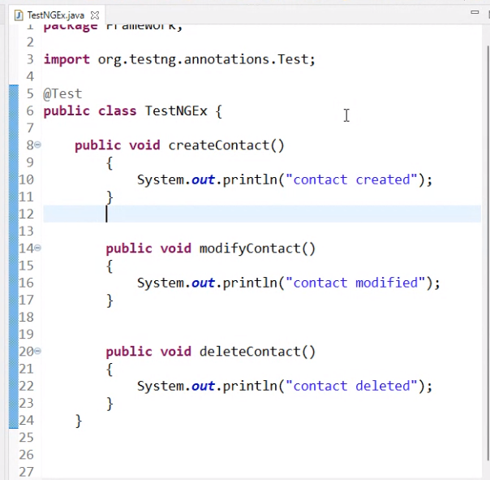

Run by giving priority

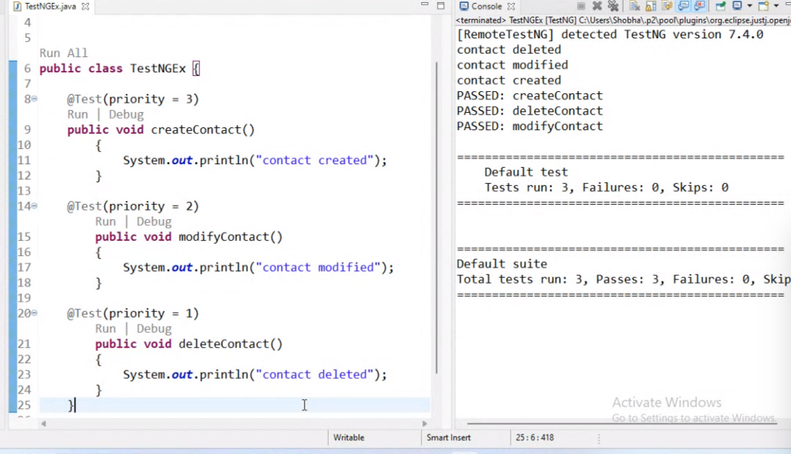

Skip some methods to be get executed.

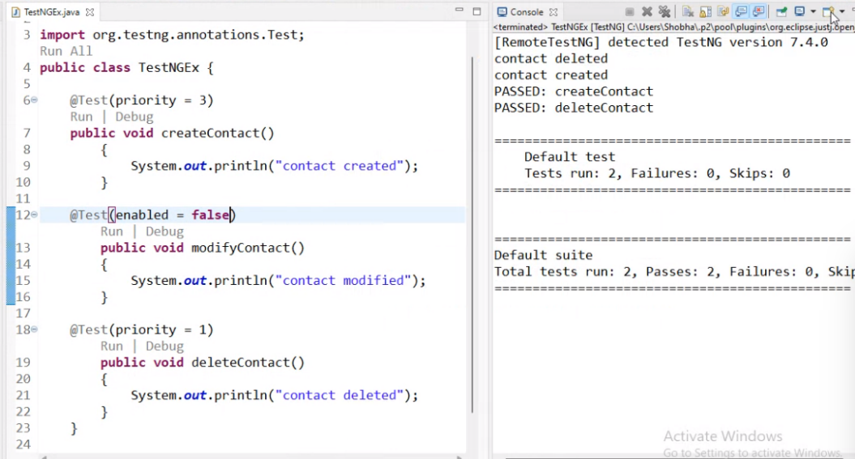

Run only when createContact method is passed

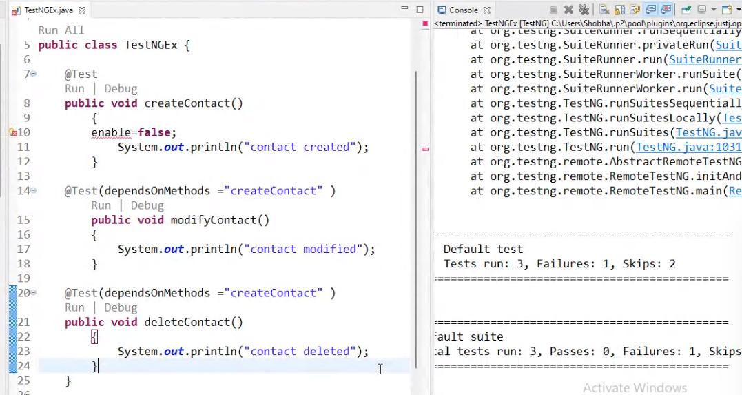

To run same method multiple times with same set of data

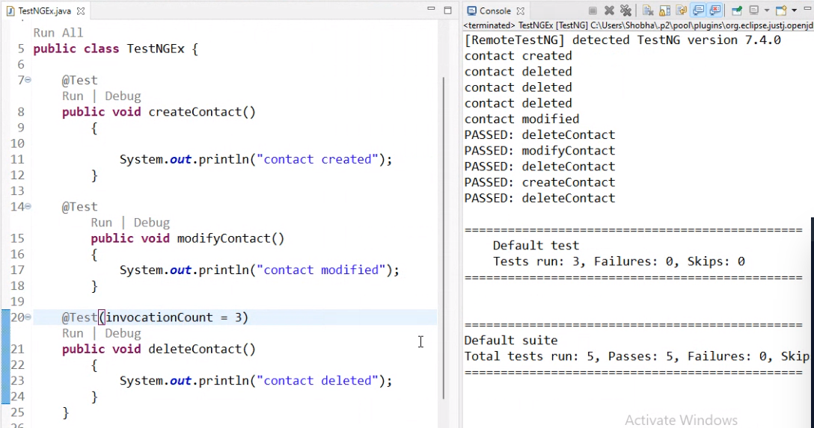

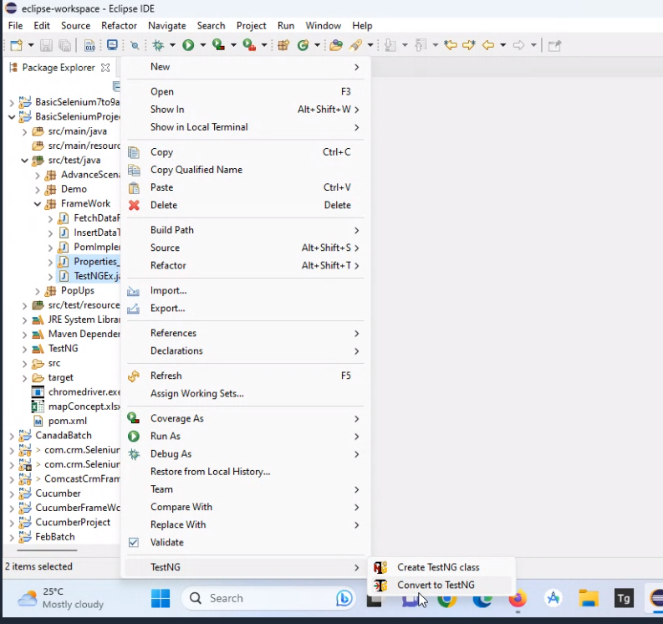

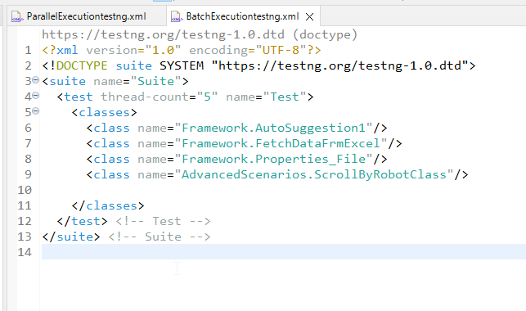

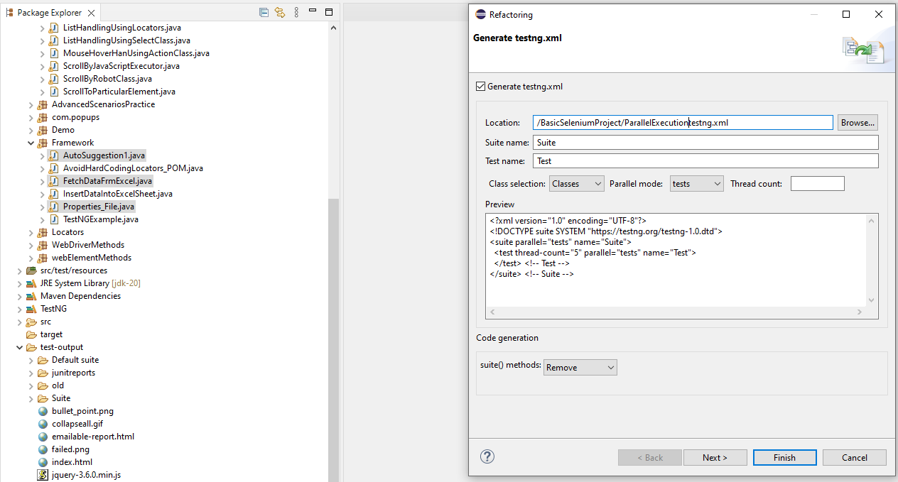

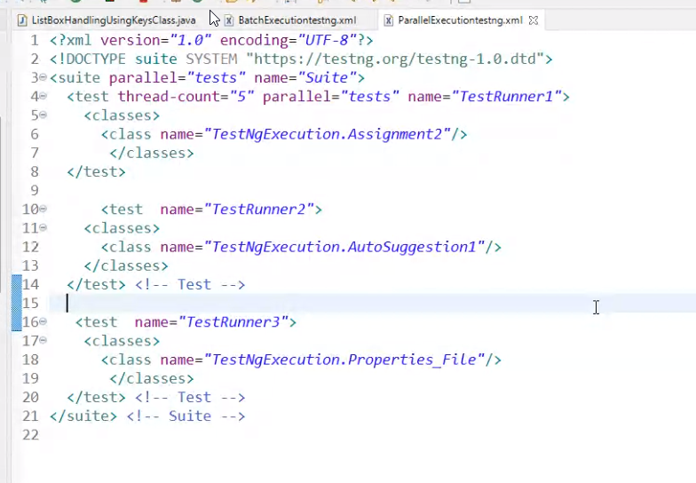

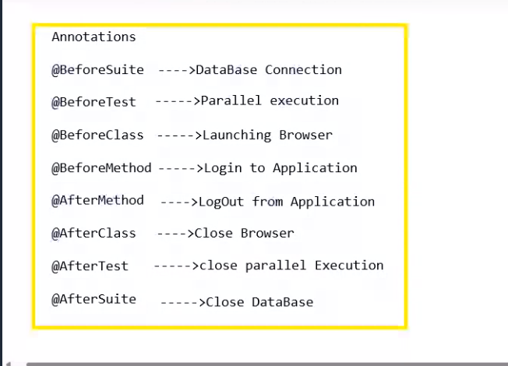

Assertion

Validating the scripts without using if else

Hard Assert

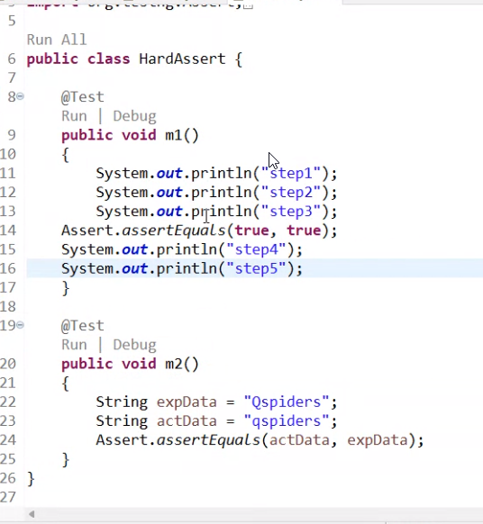

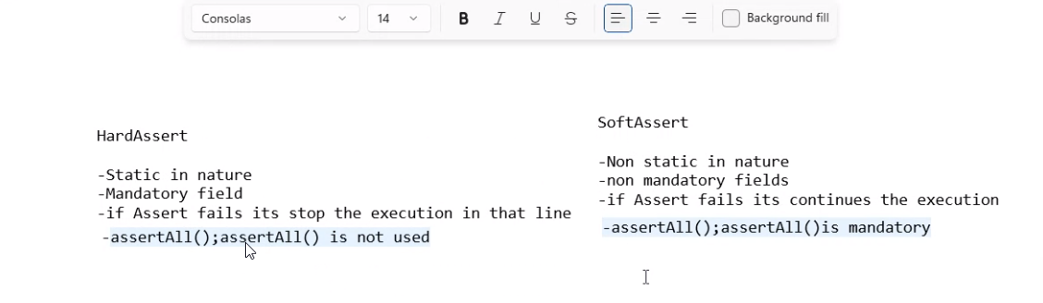

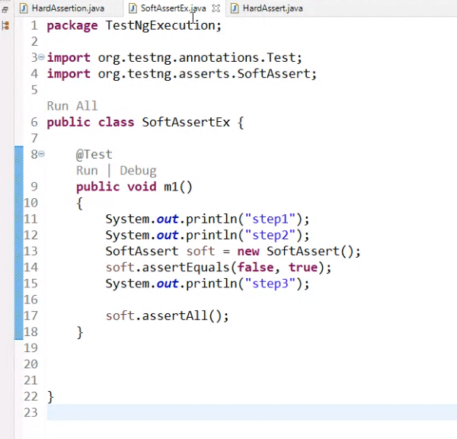

Interview questions:

1.Difference between selenium version3 and version4?

2.whats the difference between the Cssselector and xpath?

3. flipkart---samsung mobiles--fetch all the phone names along with prices

4.Explain java selenium architecture

5.Difference between find element and find elements

6.List web driver methods

7.differences between getwindowhandle and getwindowhandles

8.What is locators and types of Locators

9.differences between linked text and partial linked text

10.differences between cssSelector and xpath

11.types of xpath (absolute and relative xpath)

12.xpath---multiple attributes, position,last, index,

13.list of all web elements

14.differences between webdriver and web element methods

15.Handling multiple web elements

16.Autosuggestions Examples

17.svg elements

18.Keys class and robot class,select class

19.difference between implicit wait and explicit wait

20.syntax for all wait statements(synchronization handling)

21.syntax for all the pop ups

22.all the selenium Exceptions

IOexception---change the webdriver manager

Nullpointer---file path is not correct or data is not present in the particular cell